Original Article
Outcomes of Pedicled Tubed Groin Flaps in Coverage of Circumferential Degloving Skin loss of Fingers
Ahmed Khaled Sharaf Eldien M. B. B. Ch.; Gamal Ibrahim Elhabaa M.D.; Ayman M. Abdelmofeed M.D.; Ola Seif M.D.
Plastic Surgery Unit, General Surgery Department, Faculty of Medicine, Benha University, Egypt.

Abstract
Background: Avulsion of skin from the hand or fingers is an injury that has a dramatic presentation with significant challenge in reconstructive surgery due to the hand’s intricate anatomy and essential functional role. One of the main considerations in fingers reconstruction is the choice of an appropriate flap. Among the various flaps used in hand reconstruction, the pedicled groin flap has gained significant attention.
Objectives: The purpose of this study is to assess outcomes of groin pedicled tubed flaps as a method of reconstruction of circumferential degloving skin of fingers in terms of flap survival, sensibility, range of motion, aesthetic outcomes and wrist functions after flap separation.
Subjects & methods: This study was conducted on 20 patients who were recruited from the emergency room in Benha University Hospital presented during the period from September 2023 to September 2024 with finger’s circumferential degloving skin loss, Urbaniak class III and were treated by tubed groin flap. Assessment of the postoperative wrist, elbow and shoulder function according to DASH score questionnaire, flap survival, sensibility, range of motion, aesthetic outcomes.
Results: There were 15 (75%) males and 5 (25%) females, their age ranged from 28 - 53 years. 13 cases (65%) presented after motor vehicle accidents, 4 cases (20%) after industrial accidents and 3 cases (15%) with avulsion injury. The duration of surgery ranged from 2 – 2.5 hours, and duration of treatment till complete healing of hand and groin wounds ranged from 42 – 77 days. Only 1 case (5%) had flap failure, marginal flap necrosis happened in 2 cases (10%), groin wound infection in 1 case (5%).
Conclusion: This study demonstrated the efficacy of tubed groin flaps in the reconstruction of circumferential skin loss of fingers which simple procedure, easy to be learnt, short operative duration and minimal effect on wrist function.
Key words: groin flap, Tubed groin flap, Circumferential degloving injury of fingers, Fingers reconstruction.

Ethical committee: Approval was obtained for this study from the Ethical Committee of Faculty of Medicine, Benha University. An informed written consent was obtained from all patients regarding surgical procedures and publication of their photos.
Disclosure: No conflict of interest.

Introduction:
Inserting pedicled tubed groin flaps to replace the circumferential degloving skin loss of fingers is a helpful reconstructive technique in hand surgery. The circumferential loss of skin that results from degloving injuries reveals underlying structures including bones, tendons, and neurovascular components. These injuries are challenging to treat because they need robust covering to restore the fingers' functional and aesthetic integrity. (1) These injuries may be divided into three groups, according Urbaniak: Class I: Sufficient Circulation; Class II: Insufficient Circulation; and Class III: Complete amputation or degloving. (2) Pedicled groin flaps harvest a flap of skin and subcutaneous tissue from the groin region while preserving the vascular pedicle of the area, often the superficial circumflex iliac artery (SCIA). In situations of circumferential degloving injuries, a skin tube is formed around the injured finger to create a pedicled tubed groin flap. (3) Because this approach provides a long-lasting, well-vascularized covering while maintaining a steady blood supply from the groin region, the flap may remain viable until full revascularization of the injured area is achieved. It remains attached to the donor site until neovascularization occurs, which may require a period of immobilization. It is divided in a later surgical phase. (4) One of the key advantages of the method is the flap's robust blood supply, which is crucial for covering avascular areas of the hand, especially when tendons or bones are exposed. For the treatment of finger circumferential injuries, the groin flap is an excellent option because to its thinness, suppleness, and capacity to cover a large surface area. Additionally, since the groin region is a distant donor source, it is associated with a somewhat lower morbidity than local flaps derived from the hand itself. (5) One major problem is the limitation of upper extremity motion before flap removal, especially in elderly adults. Serious problems in the wrist, elbow, and shoulder regions may result from restrictions outside of the hand injury area. Physical treatment programs for the elbow and shoulder regions must be put in place in order to remove the limitations. Therefore, after the postoperative period, patients were given the Disabilities of the Arm, Shoulder, and Hand (DASH) score, a 30-item self-report questionnaire that measures a patient's assessment of their handicap as a consequence of upper-limb illnesses.
This research used Groin Pedicled Tubed Flaps as a procedure for rebuilding the circumferentially degloving skin of fingers and assessment of the cosmetic outcomes, flap survival, range of motion, sensitivity, and postoperative hand functionality. The DASH score questionnaire was used for assessment of the postoperative wrist, elbow and shoulder function.

Patients and Methods
This study was conducted on patients who were recruited from the emergency room in Benha University Hospital presented with circumferential degloving skin of fingers. The present study included a total of 20 patients with circumferential degloving skin loss of Fingers, Urbaniak class III. The field work was carried out during the period from September 2023 to September 2024.
Inclusion criteria: patients’ age > 15 years old, BMI < 30 kg/m² with recent circumferential degloving skin loss of 1 finger Urbaniak class III and intact interphalangeal joint and phalangeal bones with intact circulation, preserved periosteum and tendon functions.
Exclusion criteria: Patients refusing surgery, unfit for surgery, below 15 years, BMI > 30 kg/m², bone fractures or interphalangeal or metacarpophalangeal joint dislocation, open capsule of joint, lost articular surface or unstable joints, injuries with severe soiling did not improve with frequent irrigation and dressing in 72 hours. Any patient with history of any degree of disability in hand, arm or shoulder was excluded. Also, patients who are heavy smokers, major comorbid disease e.g. uncontrolled diabetes mellitus or ischemic heart disease or prior inguinal surgery were excluded.
Preoperative assessment:
Clinical history including mechanism of injury, duration from trauma to ER presentation, dominant hand, previous inguinal surgery, chronic illness and smoking. Detailed history about any functional disability in hand, arm or shoulder was taken and if there any degree of disability, the patient was excluded from the study. All patients performed detailed general clinical examinations to assess general health, presence of systemic disease and any associated injuries. Local examination of the whole upper limb, wound status, assessment of bone and tendon injuries.
Preoperative assessment of DASH score was not done due to unreliability of results due to sever influence of pain factors which would affect its results.
Routine preoperative workup:
Complete blood count, liver and kidney functions tests, coagulation profile, ECG and echocardiography when needed, viral markers (Hepatitis B, C, and HIV viral markers according to university hospital protocol). Radiological investigations to detect bone fractures e.g. x-ray.
Timing of surgery:
Clean wounds were reconstructed immediately after debridement, but contaminated wounds were given chance for 48 hours of debridement and frequent dressings (Fig. 1.).

Operating technique
The surgery was performed under general anesthesia or interscalene block with spinal anesthesia. Debridement of the degloved finger and measuring the circumferential soft tissue defect.
Flap marking: Prior to surgery, the contour of the flap was marked within the groin and the axial vessel course was determined with the help of Doppler ultrasound scanning. To mark the flap, we first identify anterior superior iliac spine and pubic tubercle, then draw a line between them which represents the inguinal ligament. By palpation we identify and mark femoral artery. The point of origin of SCIA was marked two fingers width below inguinal ligament and two fingers width lateral to femoral artery. Then, we drew a line nearly two finger breadths (about 2-3cm) below the inguinal ligament in a parallel manner to anterior superior iliac spine to identify the course of the superficial circumflex iliac artery (SCIA). Both the upper and lower borders of the flap were marked parallel to the inguinal ligament. The longitudinal axis of the flap was marked parallel to the superficial circumflex iliac artery partially above the inguinal ligament with one-third of the flap extended superior to the inguinal ligament, while the remaining two-thirds extended inferior to it. Beyond anterior superior iliac spine is a random flap in a ratio 1:1 width:length. (Fig. 2.).
Operative steps: 1. Dissection starts at the anterior superior iliac spine region of the same side of the finger with soft tissue loss. Following sequential transection of skin, subcutaneous tissue, and fascia, the flap is raised in medial direction (Fig. 3).
2. If the patient is lean and the flap is thin, fascia may be spared in initial dissection, with the incision and elevation starting only at about the medial 1/3 of the groin (sartorius muscle fascia), where the superficial circumflex iliac artery bends downwards toward the femoral artery to keep the integrity of the SCIA system.
3. The raised flap is sutured onto the defect after fat trimming. If the skin around the pedicle is loose enough, a tube may be formed therefrom. If this is not possible, moist dressing should be applied onto the subcutaneous tissue on the inner side of the flap (Fig. 4).
4. The groin wound can usually be sutured with slight tension after undermining the wound edges.
After the surgery, the upper limb was secured against accidental repositioning (which could cause the flap to detach from the hand) with a wide adhesive bandage giving the patient more freedom to move the arm and shoulder stiffness could be avoided. As it is axial blood flow and length ti width ratio about three times greater than the classic abdominal flap this allows more freely mobile fingers (Fig.5).
Patients were discharged home 2–3 days after the surgery after making sure no signs of ischemia were present within the flap. In postoperative treatment low-molecular-weight heparin had been used once a day at the therapeutic dose for 10 days. Wound healing was followed up at an outpatient surgery clinic in Benha university hospitals.
Three weeks after flap suturing, the patients were readmitted to the unit and operated on. The flap pedicle was detached from the groin, the groin wound was sutured, and the edges of the detached flap were sutured to the skin on the hand (Fig.6).

Follow-up: 1 week, 3 weeks, 6 weeks, 3 mon, 6 months and 9 months after the surgery.
The patients were asked to assess pain at surgical sites, i.e. groin and hand upon use; the patients provided their answers using a 0 to 10 numerical scale. Clinical assessment of finger movement range (full or limited movement). Assessment of their hand dexterity in daily and work-related activities (full or limited dexterity). Complete the DASH questionnaires (with help from the interviewer), which consists of 30 points of the usual daily activities translated into Arabic and fulfilled by the patients. The score is interpreted as 0 = best and 100 = worst, cut-off points to reflect severity. Cut-off scores: <15 = no problem, 16–40 = problem but working and >40 = unable to work.
Patients were given a questionnaire concerning their post reconstructive aesthetic appearance and were asked about their appearance satisfaction on 4-point Likert scale which ranged from very unsatisfied to very satisfied. Sensibility of the flap was assessed using two points discrimination method and ranged from fine to totally insensate. While range of motion was assessed by flexion of the finger and measuring the distance between the distal phalanx and the distal palmar crease.
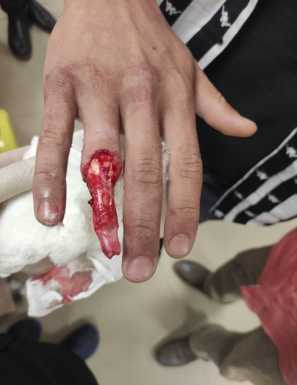
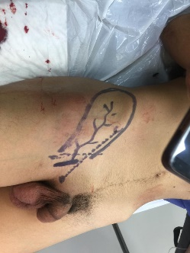 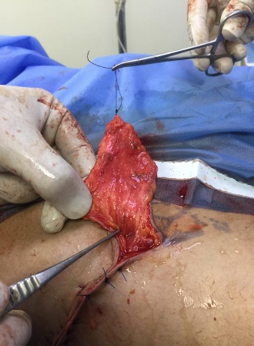 (Fig.1.): circumferential injury ( Fig.2):groin flap design. (Fig. 3.): Flap elevation.
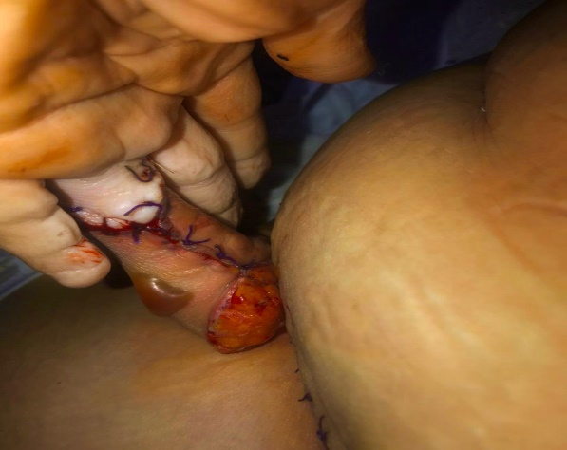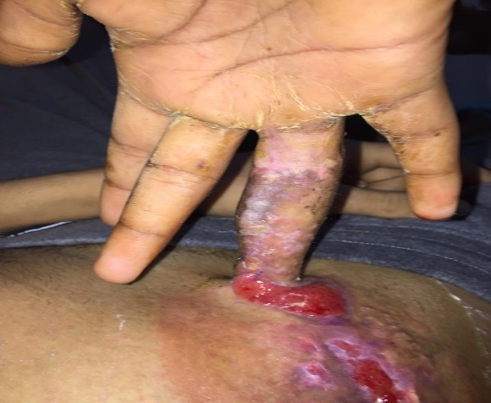
(Fig. 4.): Flap in sitting to finger. (Fig. 5.): Freely mobile finger.
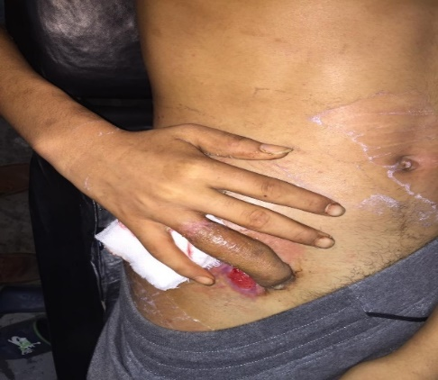
(Fig. 6.):Before flap separation after 2-3 weeks.

Rehabilitation Protocol
Serious problems might be encountered due restriction of the movement of the upper extremity before flap separation, Therefore, the patients started a minute passive wrist, elbow and shoulder joints movement after 3 days of separation then gradual increasing level of passive then active motion to regain flexibility in daily activities.
Statistical methods
Statistical analysis was performed using the SPSS (Statistical Package for the Social Sciences) version 28 (IBM Inc., Chicago, IL, USA). Continuous variables (e.g., age) were expressed as mean and standard deviation (SD) and categorial variables (e.g., sex) were expressed as frequency and percentage.

Results
Twenty patients with circumferential degloving skin loss of the fingers (Urbaniak class III) participated in this prospective interventional trial. Their average age was 42.9 ± 7.6 years, with a range of 28 to 53 years. Fifteen patients, or 75% of the total, were male, while the remaining five patients, or 25%, were female. Nineteen patients (95%) had the dominant right hand, whereas one patient (5%), had the dominant left hand. In terms of the mechanism of damage, three patients (15%) had avulsion injuries, four patients (20%) suffered industrial accidents, and thirteen patients (65%) suffered motor vehicle accidents. Six patients (30%) had hypertension, three patients (15%) had diabetes mellitus, and one patient (5%) had chronic renal disease, according to the research participants' comorbidities.
The average time from trauma to emergency room was between 100 and 140 minutes, with a mean of 118.3 ± 13.7 minutes. The average time for surgery was between 1.5 and 2.5 hours, with a mean of 2.3 ± 0.7 hours. The recovery period lasted between 42 and 77 days, with an average of 49.6 ± 7.4 days until all patients' surgical incisions in hand and groin were fully healed.
Four patients (20%) had post-operative problems, while 16 patients (80%) had none. One patient (5%) had complete flap necrosis, two patients (10%) developed marginal flap necrosis, and one patient (5%) developed a groin wound infection that necessitated the removal of several sutures and antibiotic treatment. The lengthier treatment period was caused by complications. Following the detachment of ischaemic tissues and conservative therapy, granulation tissue surface was achieved in the event of complete necrosis of the flap moved onto the palmar side of the metacarpus. This was then covered with a partial thickness skin graft.
At six months after surgery, the mean DASH score was 27.2 ± 4.6, with a range of 16 to 35. One year following surgery, the DASH score revealed that two patients (10%) had cut-off scores less than 15, sixteen patients (80%) had cut-off scores between 16 and 40, and two patients (10%) had cut-off scores more than 40.

Three patients (15%) had fine sensory recovery (less than 10 mm), fifteen patients (75%), and two patients (10%) had poor sensory recovery (more than 10 mm). This was done using two points discrimination method. After nine months, the range of motion was rated as follows: excellent in two patients (10%), good in ten patients (50%), fair in seven patients (35%), poor in one patient (5%), or fixed contractures or adhesions. Excellent range of motion was defined as 85% of full active range of motion, or finger flexion to 1 cm or less from the distal palmar crease.
After six months, six (30%) patients had exceptional patient satisfaction, nine (45%) had very good patient satisfaction, three (15%) had acceptable patient satisfaction, and two (10%) had poor patient satisfaction.
Case Presentation
Case (1): Male patient 35 years old, not diabetic not hypertensive, presented after RTA with right ring finger degloving injury and complete circumferential skin loss of distal two phalanges with intact bone and tendons of the finger. Patient was vitally stable with no other injuries. Immediate reconstruction was done to the finger by pedicled tubed groin flap. Successful separation of the flap was done three weeks later.

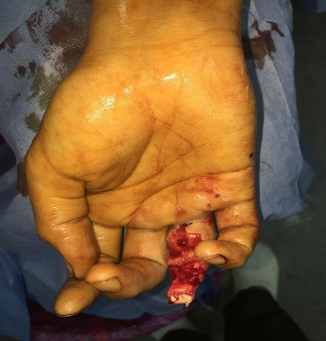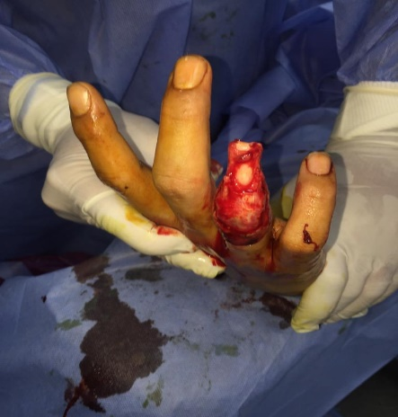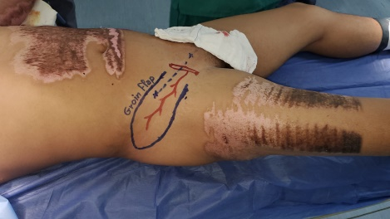
(Fig.7): circumferential skin degloving. (Fig. 8): Flap marking.

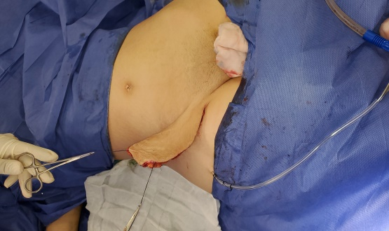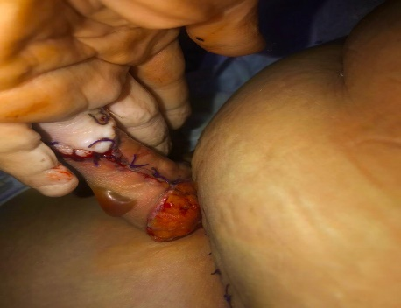
(Fig. 9): Flap elevation. (Fig.10): flap in sitting.

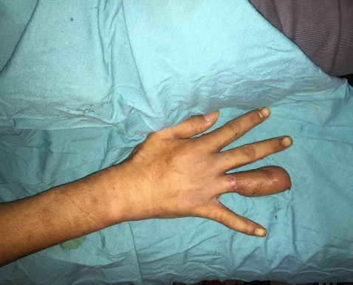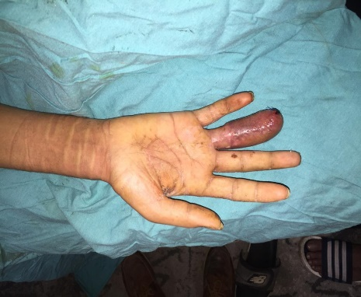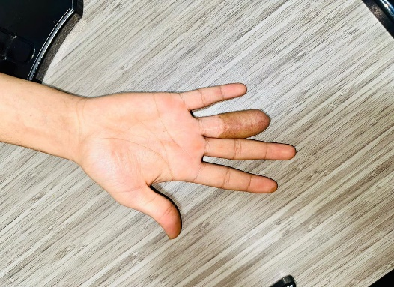
(Fig. 11): 3 month follow up. (Fig. 12): 1 year follow up.

Case (2):
Female patient 50 years old, diabetic not hypertensive, presented after industrial injury with right ring finger degloving injury and complete circumferential skin loss of distal two phalanges with intact bone and tendons of the finger. Patient was vitally stable with no other injuries. Immediate reconstruction was done to the finger by pedicled tubed groin flap. Successful separation of the flap was done three weeks later.

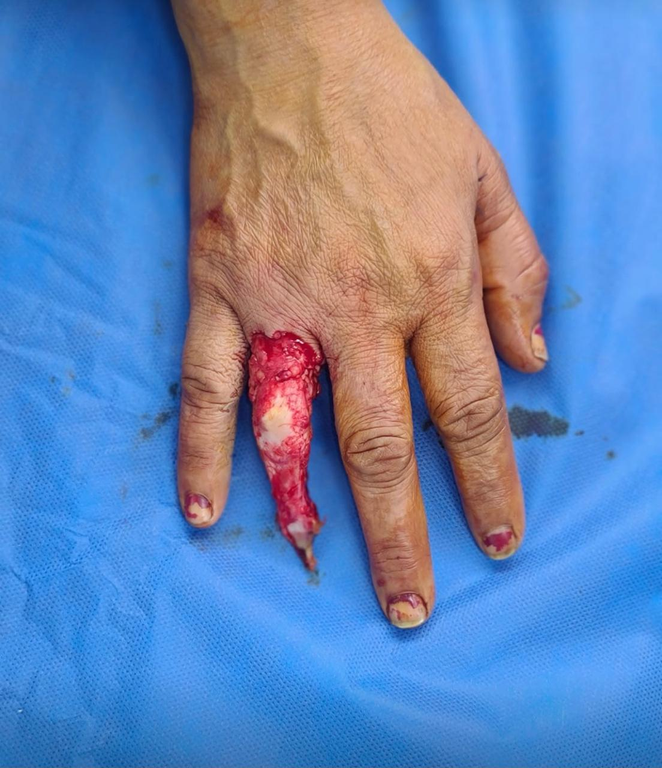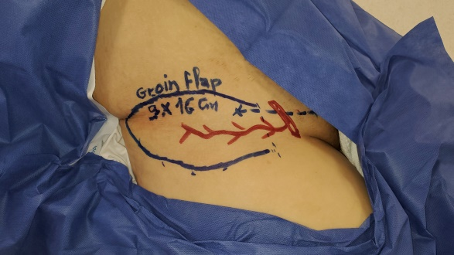

(Fig. 13): Circumferential skin degloving. (Fig. 14): Flap marking.
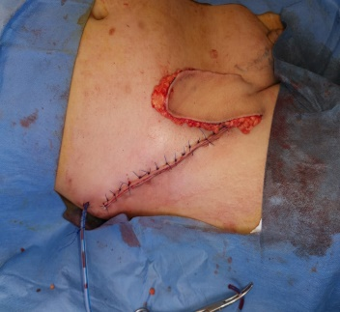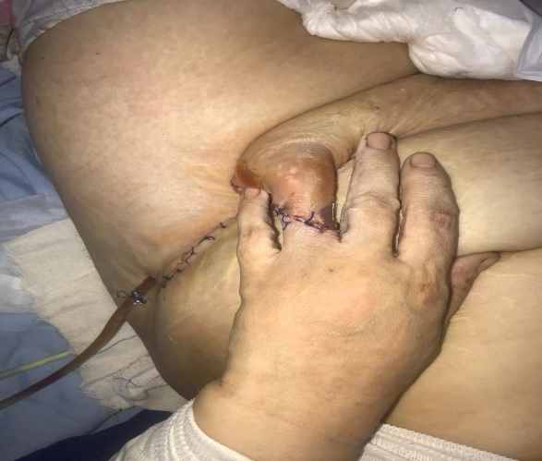
(Fig. 15): Flap harvesting and primary closure of donor site. (Fig. 16): Flap in sitting to the defect.
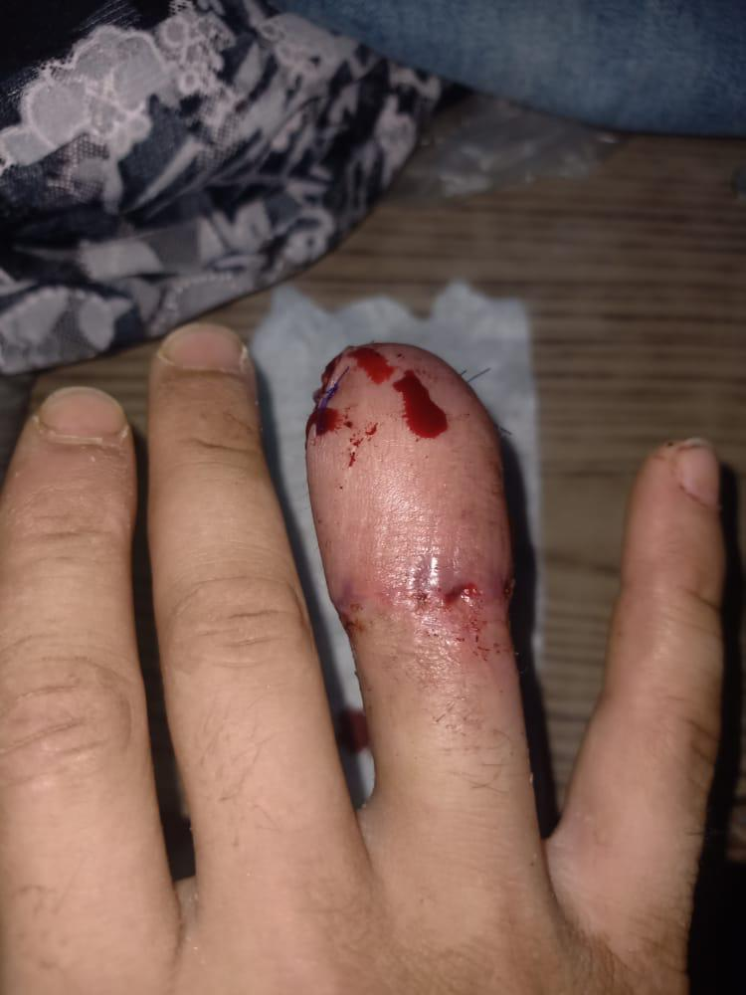
(Fig. 17): Flap after separation.

Discussion
An injury that presents dramatically is an avulsion of skin from the hand or fingers. The whole mu Because the finger's musculoskeletal unit is intact, the patient may often move the parts of his bare hand somewhat properly. The challenge for the reconstructive surgeon is to resurface the hand or finger with a superior, delicate skin covering while preserving hand function and movement. (7) The axial pattern flap used in the groin is based on the superficial circumflex iliac arteriovenous system. Since its first introduction, it has been widely utilized for soft tissue covering of the hands, fingers, and distal forearms. (8) Despite a number of disadvantages, including the requirement for flap division, sporadic debulking surgery, and patient discomfort, the groin flap offers numerous advantages, including versatility, ease of technique, relatively quick application, lack of microsurgical techniques, and lower donor site morbidity when compared to free flaps. It may also be used by those who have vascular injuries. (9,10) However, there are several disadvantages to pedicled groin flaps. The course of therapy typically consists of two parts. For a few weeks, the patient must keep their arm close to their groin, which may be challenging and limit their range of motion. (11) To improve the form and functioning of the finger, more debulking procedures may be required if the restored area becomes bulky. Furthermore, inadequate sensory regeneration may restrict the affected fingers' touch capacity. (9,11) This prospective study was carried out on patients with Circumferential Degloving Skin Loss of Fingers, Urbaniak class III, to assess the efficacy of groin pedicled tubed flap as a procedure for rebuilding circumferential degloving skin of fingers.
The average age of the patients was 42.9 ± 7.6 years. Of the patients, 15 (75%) were male, much more than the 5 (25%), who were female. This is consistent with a research by Romana Parvin et al. 2021 on pedicle groin flaps (12). According to the research, the average age of the participants was 30.6812.24 years, the majority were in the 20–29 age range, and at 38, there were more males than women (63.3%).
According to the comorbidities, patients had a higher likelihood of having diabetes mellitus (3 patients, 15%), hypertension (6 patients, 30%), and renal impairment (1 patient, 5%). In a research on the medical history of patients who had pedicled groin flaps, Wael Ayad et al. 2024(13) discovered that two (20%) had cardiac illnesses, five (50%) had hypertension, four (40%) had diabetes mellitus, and one (10%) had hepatic impairment.
Three (15%) of the patients had avulsion injuries, four (20%) from industrial accidents, and thirteen (65%) from motor vehicle accidents. This is in line with R. Krishnamoorthy et al. 2011(14), who claimed that the most common causes of hand skin avulsion include road accidents, conveyor belt injuries, and ring avulsion injuries.
The procedure lasted between 1.5 and 2.5 hours, with an average of 2.3 ± 0.7 hours. This is consistent with a study by Pfister G et al. (17) that was carried out in 2024. After three hours of surgery, a ring finger injury was treated using a thinned and tubed groin flap.
The flap was separated after three weeks, and it took an average of 49.6 ± 7.4 days to recuperate from the surgical wounds in each patient's hands and groin until they were completely healed. Complications led to a longer course of therapy. Additionally, 85 patients with soft tissue anomalies on the hand and distal forearm were treated with pedicled groin flaps in a study by Goertz et al. (6). They reported that the average duration of hospital stay was 29 ± 13 days, and the time to flap division was 24 ± 5 days.
According to the present study, 16 patients (80%) had no post-operative complications, whereas four patients (20%) had any. Only one patient (5%) had complete flap failure, two patients (10%) had marginal flap necrosis, and one patient (5%) developed an infection of the groin area that required antibiotic therapy and the removal of several sutures.
The outcomes of a groin flap procedure used to treat 69 patients with traumatic soft tissue anomalies in the upper limb are in line with a study conducted by Imran Adeel et al. in 2021 (15). Fortunately, no study participant had complete flap necrosis. A partial flap was seen in one patient (1.45%). An infection of the groin wound occurred in four individuals (5.80%).
According to a study by Acharya et al. (10), 68 patients were monitored for an average of 27 (1.6) months (range 12–60 months), which is likewise in line with the tests that were performed three to nine months after the trauma.
Two patients (10%) had exceptional range of motion, ten patients (50%) had good range, seven patients (35%) had medium range, one patient (5%), or there were set contractures or adhesions. Finger flexion to 1 cm or less from the distal palmar crease, or 85% of the complete active range of motion, was considered excellent range of motion. 18 patients had their treatment results evaluated following surgery, on average 3.7 years later, according to a study by Zyluk A. (16). Sixteen patients reported varied degrees of constraints related to both finger flexion and extension, whereas just two patients exhibited complete range of digital motion (flexion and extension). The operated hand's dexterity was significantly reduced, as shown by the average quickDASH questionnaire score of 21.5 points. None of the patients thought that their operated hand was totally effective. A significant impairment in hand function was shown by three subjects who had a quickDASH score of more than 40. The lowest functional results were seen in patients who also needed tendon restoration.
After nine months, two patients (10%) were totally insensate, fifteen patients (75%) had poor sensory recovery (more than 10 mm), and three patients (15%) had fine sensory recovery (less than 10 mm).
Nine patients (45%) had very high patient satisfaction, three patients (15%) had moderate patient satisfaction, two patients (10%) had poor patient satisfaction, and six patients (30%) had extraordinary patient satisfaction. Amouzou et al. 2017 (9) employed a groin flap to show the consequences of circumferential skin loss in the ring finger. Each patient was really happy with the scar at the donor site. Four patients claimed their flap was wonderful and they were really satisfied. For one patient, the flap was too thick. Secondary thinning was performed at four months, and the patient was satisfied with the results.
The DASH score ranged from 16 to 35, with a mean of 27.2 ± 4.6 at six months after surgery. Pedicled groin flaps were employed by Goertz et al. (6) to treat 85 individuals who had distal forearm and hand soft tissue anomalies. The average DASH score was 23 ± 17, and most of the outcomes were deemed good.

Conclusion:
The effectiveness of a tubed groin flap in reconstructing fingers with circumferential skin loss was shown in this research. Although it requires two staged operations and requires the patient to keep the limb attached to the flap for 21 days, it has a hidden scar in the groin, hairless because it is located at the lateral part of the groin, thinner than the abdominal flap and causes less tissue oedema because of the excellent venous drainage at its base. Additionally, it is a straightforward process that is easy to master, has a brief hospital stay and operation time, few problems, and a high satisfaction rate.

References:
- Höllwarth ME. Soft Tissue Trauma. In: Pediatric Surgery: General Pediatric Surgery, Tumors, Trauma and Transplantation. Springer; p. 735-743. 2021.
- Hamouya, A., Barbato, B., Beauthier-Landauer, V. & Hémon, C. 2018. Complete ring finger avulsion: Review of 16 years of cases at a Hand Emergency Unit. Hand Surg Rehabil.
- Kadry HM, El Sharkawy O, El Essawy N, Taha AA. Back to Groin; Re-Knocking the Door…. The Egyptian Journal of Plastic and Reconstructive Surgery. 44(4):487-94. 2020.
- Mishra JK, Sahu SA, De M, et al. Pedicled anterolateral thigh flap: A versatile flap for complex regional defect reconstruction. GMS Interdiscip Plast Reconstr Surg DGPW. 12. 2023.
- Jabaiti S, Ahmad M, AlRyalat SA. Reconstruction of upper extremity defects by random pedicle abdominal flaps: Is it still a valid option? Plast Reconstr Surg Glob Open. 2020;8(3).
- Goertz O, Kapalschinski N, Daigeler A, et al. The effectiveness of pedicled groin flaps in the treatment of hand defects: Results of 49 patients. J Hand Surg Am 2012;37(10):2088- 94.
- Liu, H., Guo, T., Wang, B., Wu, F., Zhang, W., Xu, T., et al. 2024. A two-stage surgery for completely degloving injury of multiple fingers: A retrospective cohort study. Journal of Hand and Microsurgery, 100151.
- Smith PJ, Foley B, McGregor IA, et al. The anatomical basis of the groin flap. Plast Reconstr Surg 1972;49:41-7.
- Amouzou KS, Berny N, El Harti A, et al. The pedicled groin flap in resurfacing hand burn scar release and other injuries: A five-case series report and review of the literature. Ann Burns Fire Disasters. 2017;30(1):57-61. 2017.
- Acharya AM, Ravikiran N, Jayakrishnan KN, et al. The role of pedicled abdominal flaps in hand and forearm composite tissue injuries: Results of technical refinements for safe harvest. J Orthop. 16(4):369-376. 2019.
- Jacobson L, Skladman R, Tuggle CT, et al. Pedicled groin flap for reconstruction of combined first webspace and dorsal hand contracture. Eplasty. 2022;22
- Romana Parvin1*, Mohd Fazle Rubby2, Mohammad Abul Kalam Azad3, Md. Toriqul Islam4 and Md Shahidul Islam Farhad5: “Groin Flap” for Reconstruction of Defects on Dorsum of the Hand. Annals of International Medical and Dental Research E-ISSN: 2395-2822 | P-ISSN: 2395-2814 2021.
- Wael Ayad, Gamal Ibrahim El-Habaa, Emad Eldeen Mostafa Abdelhafez, Mostafa Saeed Abdeen, Ola Ahmed Seif and Ahmed Abdelrahim Shoulah, Egypt, J. Plast. Reconstr. Surg., Vol. 48, No. 2, April: 99-109, 2024.
- R. Krishnamoorthy, G. Karthikeyan Indian Journal of Plastic Surgery May-August 2011 Vol 44 Issue 2.
- Imran Adeel, Ghazanfar Ali, Tahir Iqbal Mirza and Muhammad Jalil Malik, Med. Forum, Vol. 32, No. 4 95 April, 2021.
- Zyluk A.: Outcomes of coverage of the soft tissue defects in the hand with a groin flap; Pol Przegl Chir 2023; 95 (2): 32–38.
- Pfister G, Ranc C, Mathieu L Delayed management of a ring finger injury by a thinned and tubed groin flap in a forward surgical unit BMJ Mil Health 2024;170:82-83.

